WASABI / HumanEnerDIA / OVOS-EnMS

Docker Deployment Report

Version | 1.0
Date | 2026-06-08
Status | Final delivery documentation package
Purpose | Document Docker Compose deployment, configuration, startup, verification, health checks, and operational troubleshooting.
Intended audience | Operators, deployment engineers, technical reviewers, and external partner infrastructure teams.

Evidence rule: Deployment claims are based on compose files, Dockerfiles, setup and verification scripts, and local compose validation.

Table of Contents
1. Deployment Overview
2. Compose Service Topology
3. Docker Compose Services
4. Networks, Volumes, And Ports
5. Environment Variables And Configuration
6. Startup, Shutdown, And Reinstall Procedures
7. Verification Scripts And Health Checks
8. Production Hardening And Troubleshooting
9. Limitations And Assumptions
10. Evidence References

Deployment Overview
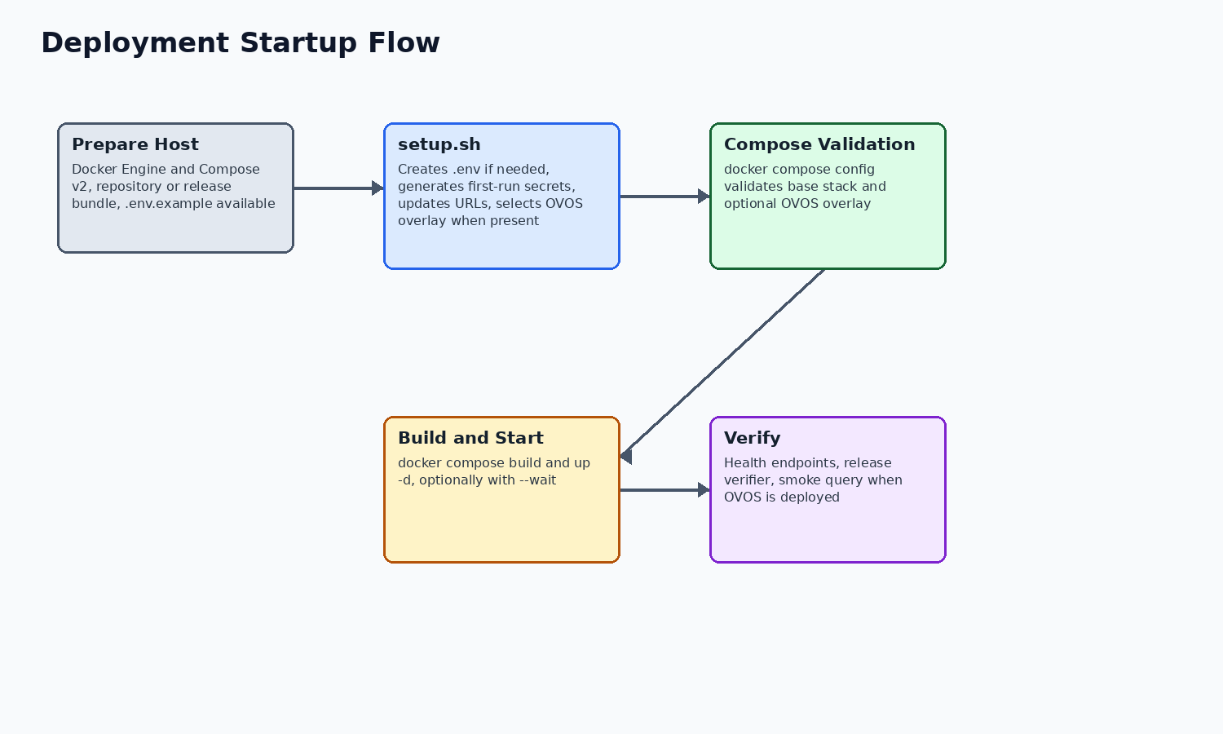
Figure 1. Deployment preparation, setup, validation, build, start, and verification flow.
The deployment target described by the repository is a Linux host running Docker Engine and Docker Compose v2. The base stack is defined by docker-compose.yml. Full-stack release bundles can include docker-compose.ovos.yml to add the OVOS runtime and skill.
The setup helper is the intended guided path. It creates .env from .env.example when needed, generates first-run secrets for placeholders, validates Docker Compose, builds images, and starts the stack. It also adjusts OVOS_BRIDGE_HOST when an OVOS overlay is present.

Compose Service Topology
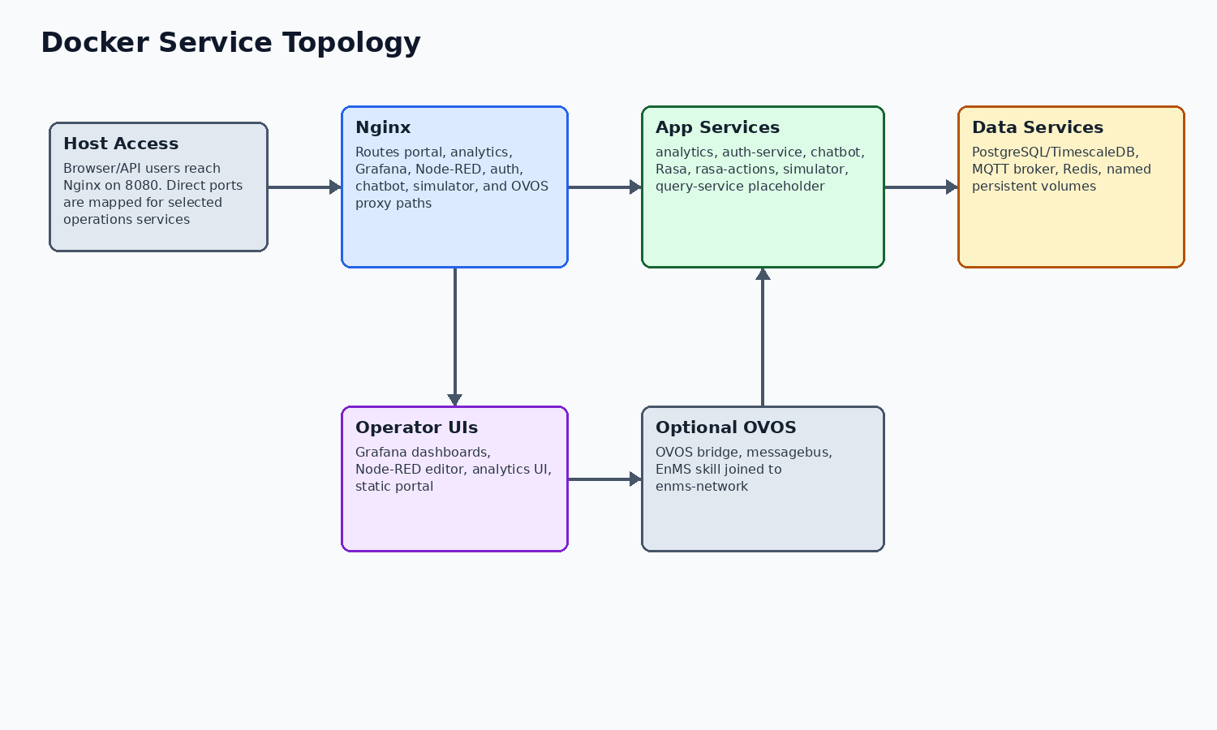
Figure 2. Docker Compose service topology and optional OVOS attachment.
The base deployment uses one Docker bridge network for HumanEnerDIA services. Nginx is the browser/API gateway; analytics, auth-service, chatbot/Rasa, simulator, Node-RED, Grafana, PostgreSQL/TimescaleDB, MQTT, and Redis communicate on the internal network. OVOS can be added as a separate service joined to the same network.

Docker Compose Services
Service | Image or build context | External port/path | Responsibility | Healthcheck
nginx | nginx:1.25-alpine | 8080; 8443 mapped but HTTPS server block is optional/commented until certificates are configured | Public gateway, portal/static hosting, reverse proxy | Yes
postgres | timescale/timescaledb:latest-pg16 | 5433 | PostgreSQL with TimescaleDB extension and persistent data volume | Yes
mqtt | build ./mqtt | 1883, 9001 | Mosquitto telemetry broker with configured credentials | Yes
redis | redis:7-alpine | 6380 | Redis cache and Pub/Sub support for analytics event paths | Yes
simulator | build ./simulator | internal 8003 | FastAPI synthetic telemetry generator loaded from database machines | Yes
nodered | build ./nodered | 1881 | MQTT-to-database ingestion and automation flow runtime | Yes
grafana | grafana/grafana:10.2.0 | 3001, /grafana | Provisioned dashboards backed by PostgreSQL/TimescaleDB | Yes
analytics | build ./analytics | 8001, /api/analytics | FastAPI analytics, KPI, reports, ISO 50001, and OVOS proxy APIs | Yes
query-service | build ./query-service | 8002 | Reserved placeholder; healthcheck disabled and not a readiness signal | No
auth-service | build ./auth-service | 5500 | Flask auth, admin, contact, pilot/application APIs | Yes
rasa-actions | build ./chatbot/rasa | 5055 | Rasa custom action server | Yes
rasa | build ./chatbot/rasa | 5005 | Rasa NLU text chatbot server | Yes
chatbot | build ./chatbot | 5006 | Express backend and built chatbot frontend proxying to Rasa and OVOS | Yes

Networks, Volumes, And Ports
All core services join the Docker bridge network named by ENMS_NETWORK_NAME, defaulting to enms-network. The OVOS overlay also joins that network and depends on analytics service health.
Persistent named volumes include PostgreSQL data, MQTT data/logs, Redis data, Node-RED data, Grafana data, and OVOS/supervisor logs when the OVOS overlay is used.
Resource | Configured name/default | Purpose
Network | ${ENMS_NETWORK_NAME:-enms-network} | Service-to-service communication
postgres-data | ${VOLUME_PREFIX:-enms}-postgres-data | PostgreSQL/TimescaleDB persistent data
grafana-data | ${VOLUME_PREFIX:-enms}-grafana-data | Grafana runtime data
redis-data | ${VOLUME_PREFIX:-enms}-redis-data | Redis append-only persistence
mqtt-data/logs | ${VOLUME_PREFIX:-enms}-mqtt-data and -mqtt-logs | Mosquitto runtime data and logs
ovos-logs | ${VOLUME_PREFIX:-enms}-ovos-logs | OVOS runtime logs when overlay deployed

Environment Variables And Configuration
.env.example is the safe public configuration template. The real .env file is intentionally not included and must not be committed or copied into documentation. The setup helper generates first-run values for placeholders and preserves existing non-placeholder values.
Important configuration groups include database credentials, Redis password, MQTT credentials, Grafana admin credentials, Node-RED credential secret and password hash, JWT secret, API key, server IP/frontend URL, Grafana root URL, simulator controls, OVOS bridge host/port/timeout, and SMTP/admin settings.
- Use .env.example in documentation, not .env.
- Rotate generated first-run credentials before production exposure.
- Set DNS, TLS, firewall rules, and public URLs explicitly for production.

Startup, Shutdown, And Reinstall Procedures
Supported startup paths are ./setup.sh or manual Docker Compose commands after .env is prepared. Supported stop/start procedures use docker compose down/up or docker compose restart without deleting volumes. Destructive volume deletion is not part of routine operations.
Procedure | Command or source | Notes
Guided setup | ./setup.sh [--server-ip HOST] [--no-build] [--no-start] | Creates/updates .env, validates compose, builds and starts by default.
Manual validation | docker compose config | Base validation succeeded in this documentation pass.
Manual start | docker compose build; docker compose up -d | Use after .env has no placeholders.
Restart service | docker compose restart analytics | Use service-specific logs to confirm recovery.
Stop without deleting data | docker compose down | Keeps persistent volumes.
Clean reinstall | Only when data removal is intended; do not use down -v casually | Back up data first.

Verification Scripts And Health Checks
The repository provides release and API verification scripts. These scripts are evidence of intended operational checks, but their success depends on a running stack and reachable services. In this documentation run, compose validation was executed; live health checks were not implied.
Check | Purpose | Evidence/status
docker compose config --quiet | Validate Compose syntax/resolution | Ran successfully for base HumanEnerDIA stack.
docker compose -f /home/ubuntu/ovos-llm/docker-compose.yml config --quiet | Validate OVOS-only compose | Ran successfully.
scripts/verify-wasabi-release.sh --skip-shop | Checks Nginx, analytics, OVOS bridge, OVOS smoke query when services are running | Script inspected; not run because runtime stack health was not established.
scripts/validate_api_documentation.sh | Checks critical analytics/API documentation endpoints against a running service | Script inspected; not run because it requires live analytics and test data.
Service healthchecks | Container-level checks for most services | Configured in docker-compose.yml; query-service disabled.

Production Hardening And Troubleshooting
The repository provides release-oriented defaults, placeholders, health checks, and hardening notes, but it should not be represented as automatically production-hardened. Operator action is required for DNS, TLS, firewall restrictions, credential rotation, backups, and monitoring policy.
Symptom | Likely area | First checks
Portal does not load | Nginx or portal static files | curl /health; docker compose logs nginx
Analytics API returns 500 | Analytics, PostgreSQL, Redis | logs for analytics/postgres/redis; /api/v1/health
No new telemetry | Simulator, MQTT, Node-RED | logs for simulator/mqtt/nodered; Node-RED flow status
Grafana unavailable | Grafana or database | Grafana health endpoint; credentials and volume status
Auth errors | auth-service, database, SMTP | /api/auth/health; auth-service logs
OVOS voice path unavailable | OVOS bridge/messagebus or analytics proxy | OVOS /health; analytics /api/v1/ovos/voice/health
query-service health missing | Expected placeholder state | Do not use query-service as readiness blocker.

Limitations And Assumptions
The following items should be reviewed before stakeholder distribution. They are documented to avoid overstating the current implementation.
Item | Status
query-service | Placeholder only; Docker service exists, healthcheck disabled, and it is excluded from release readiness expectations.
Runtime verification | This documentation package records compose validation. Live health checks require a running deployment and are not implied unless run separately.
OVOS release artifact | The OVOS source tree may contain local GGUF model files, but release notes state optional GGUF weights are not bundled by default.
Third-party EnMS support | OVOS portability is through a HumanEnerDIA-compatible API or adapter/proxy, not zero-code support for arbitrary vendor APIs.
Reports V2 | V2 report code is implemented, but some service calculations use derived/proportional or placeholder values; final stakeholders should review report semantics before audit use.
Simulator inventory | The simulator code supports boiler in addition to compressor, HVAC, motor, pump, and injection molding. One simulator info response still lists five machine types.
Security posture | The codebase provides secret placeholders, generated first-run credentials, JWT/bcrypt auth, health checks, and hardening guidance. Public production exposure still requires operator DNS/TLS/firewall/credential work.

Evidence References
The table below lists the main local evidence used for this document. It is not a full file inventory; it identifies the sources behind the material claims.
Topic | Evidence
Base compose | docker-compose.yml
OVOS overlay | scripts/release/docker-compose.ovos.yml
Setup helper | setup.sh
Verifier | scripts/verify-wasabi-release.sh
Operations | docs/OPERATIONS_RUNBOOK.md; docs/DELIVERY_READINESS.md
OVOS Docker | /home/ubuntu/ovos-llm/Dockerfile; /home/ubuntu/ovos-llm/docker-compose.yml

